Carter lab dynactin prep from frozen porcine brains, using SP-Sepharose column
(Based on Bingham et al. 1998)

Reagents:

1 M PIPES pH 7.2: 151g PIPES (Melford) in 500ml H₂O (pH 7.2 with KOH – takes practically a full 50ml tube of KOH pellets, plus 5 M KOH for finer adjustment).

10 x Homogenisation buffer (pH 7.2):

350 mM PIPES pH 7.2 | 87.5 ml (1 M)
50 mM MgSO₄ | 12.5 ml (1 M)
10 mM EGTA | 12.5 ml (0.2M, pH 8.0 with NaOH)
5 mM EDTA | 12.5 ml (0.1 M)
 |  | 250ml total

1 x cold PBS (1 x 500 ml and 1 x 1 L)

SP-Sepharose buffers:
Buffer A |  | Buffer B
35 mM PIPES pH 7.2 | 105 ml (1 M) | 35 mM PIPES pH 7.2 | 70ml (1 M)
5 mM MgSO₄ | 15 ml (1 M) | 5 mM MgSO₄ | 10ml (1 M)
1 mM EGTA | 15 ml (0.2 M) | 1 mM EGTA | 10ml (0.2 M)
0.5 mM EDTA | 15 ml (0.1 M) | 0.5 mM EDTA | 10ml (0.1 M)
1 mM DTT | 3 ml (1 M) | 1 mM DTT | 2ml (1 M)
0.1 mM Mg.ATP | 3 ml (0.1 M) | 0.1 mM Mg.ATP | 2ml (0.1 M)
 |  | 1 M KCl | 151.2 g
3L total |  | 2L total

MonoQ buffers:
Buffer A |  | Buffer B
1x HB | 100 ml (10x) | 1x HB | 50 ml (10x)
1 mM DTT | 1 ml (1 M) | 1 mM DTT | 0.5 ml (1 M)
 |  | 1 M KCl | 250 ml (2 M)
1 L total |  |  | - ml total

Gel Filtration buffer:
25mM Hepes pH 7.4 | 25 ml (1 M)
150mM KCl | 75 ml (2 M)
1mM MgCl₂ | 1 ml (1 M)
5mM DTT | 5 ml (1 M)
0.1mM Mg.ATP | 1 ml (0.1 M)
1 L total

Brain collection and freezing protocol

Prepare beforehand:
Coordinate with the butcher and arrange transport.
500ml 1 x homogenization buffer (PIPES based, from the brain prep protocol),
1x 1L and 1x 500 ml bottles of 1 x PBS
Put the 1x HB and 1 L PBS in the cold room ready for your return.
Glove liners are helpful for working in the cold room while cleaning the brains.

Take to the butcher:
Gloves,
Zip lock bags (we use 127x191mm size ones, which fit 2 brains each),
500 ml 1x PBS (ice cold, about 125 ml per 2 brains).
Big polystyrene box with ice (about 2/3 full).

At butcher:
- Pour a little ice cold PBS into each zip lock bag (~5cm depth),
- You can fit two brains per bag, then close the bag and immediately bury so that the brains inside are surrounded by ice
- Return to the lab.

Upon return to the lab:
- Get large bucket of LN₂ and put on trolley outside cold room door (do not bring into enclosed space of cold room)
- Get one new zip lock bag per brain, and open them so that they are easy to handle with dirty hands later on.

In cold room:
- Clean and freeze the brains one by one.
- Pour one brain into your non-dominant hand or in a large weighing boat. If very dirty, rinse with PBS in your hand.
- Use other hand to remove major blood vessels and white matter. Take care to retain the cerebellum. You can “open up” the brain and you may be able to remove two quite large bundles of blood vessels by plucking them out. Aim to remove the meninges and surface blood vessels on the brain (sometimes they peel off easily, sometimes it requires a bit more plucking)
- Put brain in new zip lock bag and wash in PBS
  - Pour on a bit of PBS, gently jiggle the bag to rinse the brain, and then pour out the PBS while retaining the brain in the bag. If the waste PBS is very dirty, repeat the PBS wash.
- Wash as before with 1x HB, draining the HB away afterwards.
- Close bag (excluding extra air, this will make flattening the brain easier)
- Quickly flatten brain in bag - place the bag on bench, flatten firmly with fingertips. Immediately upon flattening, spread thinly in bag, optionally fold in half, snap freeze in LN2. The aim is not to completely pulverize the brain, but rather to flatten it so that it is in a thin layer in the bag for rapid freezing and easy handling when thawing.
- Put in -80 °C freezer inside labelled larger bags (secondary containment important because sometimes the zip lock bags fracture)

When ready to prep the brain:
- Retrieve from freezer and place bag within another bag for secondary containment.
- Hammer to break the frozen brain into small chunks. Use layers of paper towels to protect the bags from being punctured between the sharp edges of the frozen brain and the hammer.
- When using frozen brains, use room temperature lysis buffer. If you use cold lysis buffer the whole mixture will seize up and freeze in the blender.

Day -1
- Prepare 1M PIPES and 10xHB cover in foil and store in fridge.
- Prepare SP Sepharose buffer A and B (except ATP + DTP which are added fresh tomorrow), store in measuring cylinders in cold room overnight.
- Make/check AKTA and centrifuge bookings.
- Wash SP-column in 5CV water overnight.
First day
- Prepare 500ml lysis buffer (1xHB + 4 Complete tablets + 4ml 200mM PMSF + 1mM DTT)
- Add DTT and PMSF just before brain homogenization.
- Retrieve three frozen pig brains from freezer. Hammer brains to break up into smaller pieces (hammer padded with some paper towels to avoid breaking bag, within secondary bag to contain brains incase the inner bag breaks).
- Blend brains with ~440ml lysis buffer (350ml to start with then add as much as needed to top up 3xTLA 16.250 tubes – 250 ml each so aim for 750 ml total volume. Aim for 1 brain per TLA tube.
- When using frozen brains, use room temperature lysis buffer, otherwise the mixture will get too cold, seize up and be un-blendable.
- First blend with several short pulses @ high speed to mash chunks of pig brain, later use 4x15s pulses with 15s waiting in between. Never take hand off top of blender lid whilst the blender jug is on the base.
- Set blended lysate stirring in beaker on stirrer – look for ice crystals to melt. Can take 30 min. While the brains are melting, set the SP column equilibrating.
- Add ATP and DTT to SP-Sepharose buffers, filter and set up S-column wash (2CV buffer B, 2CV buffer A, 10 ml/min, method should take around 90 minutes – will be finished by end of second spin).
- Prepare and put in cold room:
  - 4 x TLA 16.250 tubes
  - 6 x Ti45 tubes
  - 3 x 600 ml beaker
- Pellet cell debri in TLA 16.250 at 16k rpm for 15min at 4°C. *pre-cool*
- Spin the supernatant in Ti45 (~300ml) at 45k rpm for 50min at 4°C. *pre-cool*
- Carefully decant the supernatant to 600ml beaker (+2 more for filtering) Avoid the loose parts of the pellet even if this means losing some supernatant.
- Filter the supernatant through GF (glass fiber) pre-filter (50ml syringe) then 0.45 μm filters (25ml syringe). If not luer lock syringes, hold on to filter so it doesn’t pop off. Filter gently to avoid foam and bubbles. Change filters when resistance becomes too high or if foam is seen.
SP column
- Wash AKTA sample input with H₂O and buffer A (should be stored in 20% EtOH). May have to purge with syringe.
- Load the lysate onto SP-Sepharose column (CV ~250ml) at 4 ml/min. Collect flow through.
- Wash the column until white with SP-Sepharose buffer A, 0.3% buffer B at 10 ml/min
  - Typically have to wash with 4-6 CV before resin is sufficiently white.
  - Can place AKTA programme on hold at this stage, then skip to next breakpoint when ready to elute
  - Elute with two part linear gradient, collect 15 ml fractions (60 tubes, ie 4 AKTA pure 15 ml tube blocks) 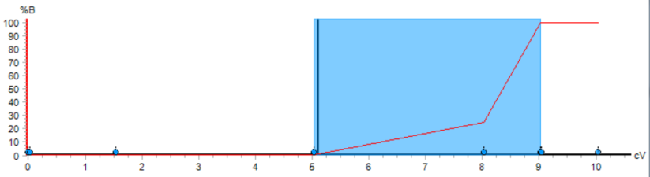
Type | Target % B | Length (CV)
Linear | 25.0 | 3
Linear | 100 | 1

MonoQ
- As soon as the dynactin peak has come off the SP column, stop the SP run and begin equilibrating the MonoQ 16/10 column
  - Wash MonoQ with 2CV water, 2CV B, 2CV 95% A with 5% B. Use 0.22 µM inline filter upstream of the column.
- Pool the bulk of SP Sepharose peak and filter through 0.22 µm filter (avoid bubbles)
  - Load onto MonoQ 16/10 at 5 ml/min.
  - As the protein loads onto the column, the 0.22 µm pre-filter will clog up, increasing the pressure. Control flow rate based on delta-column pressure. Collect the flow through.
  - When loading slows too much, change 0.22 µm filter taking care not to introduce air into the column.
  - Once loaded, wash with 5% B for 10 CV, 5 ml/min.
  - Elute in a 3 step gradient
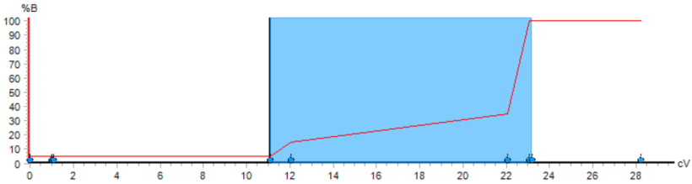
Type | Target % B | Length (CV)
Linear | 15 | 1
Linear | 35 | 10
Linear | 100 | 1
- Ideally run slowly overnight so that the peak comes off the column in as you arrive on Day 2.
- Overnight, wash the G4000 from storage in 20% EtOH to water (2 CV)

Day 2 – G4000
- Equilibrate the G4000 with 2CV GF150.
- Pool dynactin containing peak (Approx. 39 mS/cm, though this varies by AKTA). Run gel of fractions to verify if unsure.
- Begin cleaning-in-place protocols for MonoQ then SP Sepharose columns (see below).
- Concentrate dynactin containing peak using 4ml 100K MWCO Amicon concentrator, pre-washed with MonoQ A buffer. 4’C, 2000 RCF, 3-5 min between mixing. *pre-cool centrifuge*
  - Concentrate to approx. 2.5ml.
- Run G4000
  - 0.22 µm filter or spin sample (max speed in benchtop centrifuge) before loading
  - Load dynactin onto column using 5 ml sample loop, (first wash 2xH20, 2xGF150)
  - Run at 3 ml/min, collect 2 ml fractions (2 ml 96 deep-well block)
- Pool the dynactin peak, concentrate to approx. 3-4mg/ml using 4 or 15 ml 100K MWCO Amicon concentrator, *pre-cool centrifuge*.
- Freeze in liquid N₂ in 3-5 µl aliquots
  - No need to add glycerol before freezing
  - Make larger aliquots for complex formation experiments

SP-sepharose washing procedure:
  - After purification method is finished the column is in 100%B.
  - Wash in down-flow (self-packed column)
  - Wash the column with 3-5CV 2M NaCl.
  - Wash with 2-3CV 1M NaOH.
  - Wash with 3-5CV 2M NaCl.
  - Wash with 3-5CV H₂O.
  - Equilibrate into 20% EtOH for storage.

MonoQ 16/10 washing procedure
- After purification method is finished the column is in 100%B.
- Wash in up-flow
- Wash with 2-3 CV 1 M NaOH
- Wash with 3-5 CV 2 M NaCl
- (Wash with 1 CV 1 M HCl – only do this when column performance drops)
- (wash with 1 CV 75 % acetic acid – only do this when column performance drops)
- Wash with 3-5 CV NaCl
- Wash with 2-5 CV H₂O
- Equilibrate into 20% EtOH for storage

Column vital stats:
Column | CV (ml) | Max pressure (MPa) | Flow rate (ml/min) | Stored in
SP-sepharose | 250 | 0.3 | 4 | 20% EtOH
MonoQ 16/10 | 20 | 3 | 5 | 20% EtOH
G4000 TOSOH | 210 | 2 | 3 | 20% EtOH
Sample load pump 960 |  | 2 | 5

SP column typical appearance:
SP column during loading | SP column after 2L washing, ~5 or 6 preps since re-packing column. General red goes away, tight red band stays. The resin may look slightly cream/buff coloured  The tight red band will elute after the bulk of the dynactin peak;  Do not put any of this red material on the MonoQ.
Typical SP peak. Pool fractions from first peak. (E.g. approx. from 2A5 to 3C5 in this case)
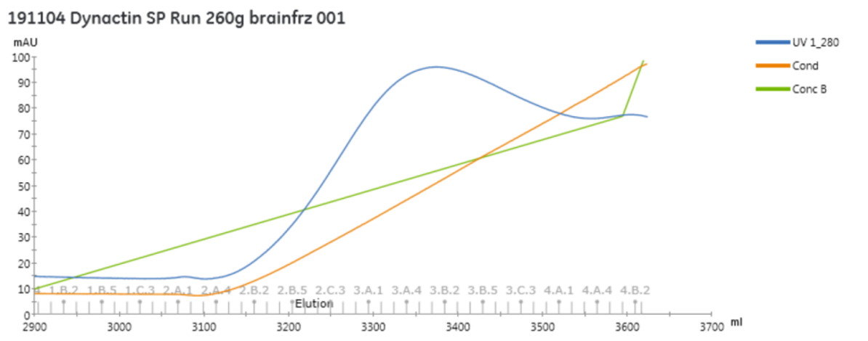

Typical MonoQ peak
